Chapter 7 Practice Problems

- Which of the following best illustrates the concept of consumer surplus?

  - A thirsty athlete pays $0.85 for a cold drink when she would have gladly paid $1.50 for the drink.
  - An individual who is willing to accept a job at $7.50 per hour is offered $7.00 per hour.
  - An individual pays the sale price of $15.00 for the same shirt that the individual refused to purchase earlier at $18.00.
  - An individual finds that the price of artichoke, a food she dislikes, has been reduced by 50 percent.
  - A wood-carver has a marginal cost of $5.00 for a unit of output, but sells that unit at $6.00.

- Which of the following is true of a price floor?

  - The intention of the government in creating the price floor is to assist the producers of the good.
  - To have an impact in the market for the good, the price floor should be set below the existing market price of the good.
  - An effective price floor will increase the quantity demanded of the good.
  - The price floor would tend to create a shortage of the good in the market.
  - The creation of the price floor would not change the quantity supplied of the good if the supply curve were upward-sloping to the right.

- Use the graph below to determine what price and quantity customers will pay given the government imposes a price ceiling of $8.

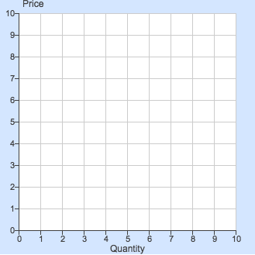
S
D
Price ceiling

Quantity Price
  - 2 $2
  - 2 $8
  - 5 $5
  - 5 $8
  - 8 $8

- Use the graph below to answer the following questions.

Graph 1 Graph 2

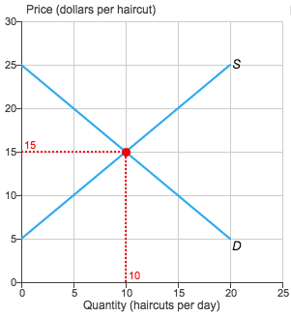

  - If only 5 haircuts are made a day, how much consumer surplus will each client receive?

  - In Graph 1, shade the region that represents the total consumer surplus. Then, calculate its value.

  - If only 5 haircuts are made a day, how much producer surplus will the hairstylist receive?

  - In Graph 1, shade the region that represents the total producer surplus. Then, calculate its value.

  - The government decides to set a price floor so that hairstylists receive nothing less than $20 a haircut.

    - Will this create a shortage or a surplus? How large will the shortage or surplus be?

    - Assuming no black market forms, shade the regions of consumer surplus, producer surplus, and deadweight loss in the space provided in Graph 2.

    - Calculate the value of the new consumer and producer surplus. Is each larger or smaller than its original value?

- Use the following table to answer the questions below about the tent market. [calculate elasticity, sketch the d&s curves. Shifts dependent on inferior, normal, complement, or substitute goods, identify changes to cs, ps, and dwl, effects of an effective price ceiling]

Price | Q_{D} | Q_{S}
20 | 10 | 10
40 | 6 | 50

  - Calculate the E_{D}. Does the good have a perfectly elastic, relatively elastic, perfectly inelastic, relatively inelastic, or unit elastic demand?

  - Calculate the E_{S}. Does the good have a perfectly elastic, relatively elastic, perfectly inelastic, relatively inelastic, or unit elastic supply?

  - Sketch a demand and supply graph.

    - Label the equilibrium price and quantity given the information in the table.
    - Shade the consumer surplus.
    - Shade the producer surplus.

  - The income elasticity of demand for tents is 3/2. Your income increases significantly.

    - Sketch a new demand and supply graph and shade the new producer surplus.
    - Has the producer surplus increased, decreased, remained the same, or is the change indeterminate?

  - The government imposes an effective price ceiling. Sketch a new demand and supply graph showing the effective price ceiling.

    - Identify whether the price ceiling results in a shortage or surplus.
    - Shade the consumer surplus.
    - Shade the producer surplus.
    - Shade the area of deadweight loss.

